C PROGRAMMING TO FIND THE GIVEN NUMBER IS EVEN OR ODD

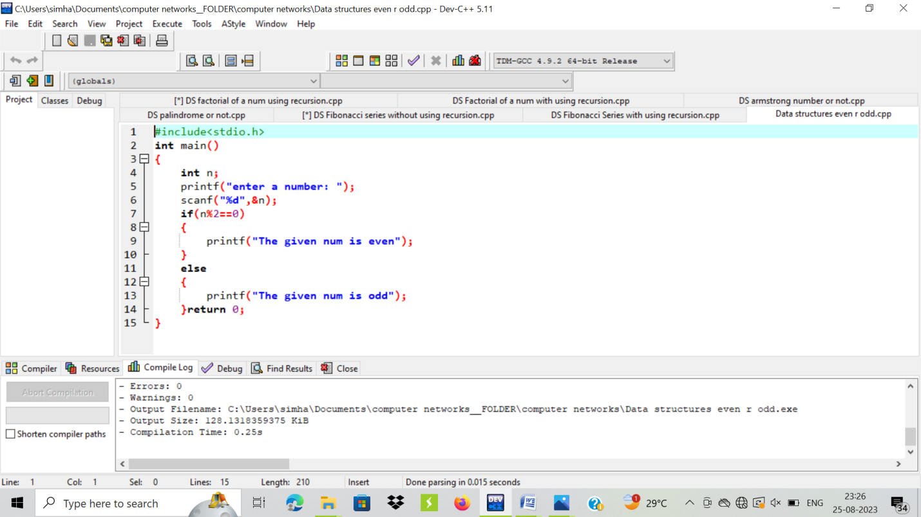

OUTPUT:

